FSE-4 ACCREDITION

Abish Kurungatadathil :462423

Skill Tracker

Design Document

1. **Urls**

|  |  |
| --- | --- |
| **Name** | **URL** |
| **Cloudfront** | [**https://d1ggjsdrqrpf52.cloudfront.net/index.html**](https://d1ggjsdrqrpf52.cloudfront.net/index.html) |
| **Apigateway url** | [**https://m3sqg9vzjj.execute-api.us-east-1.amazonaws.com/dev/admin/**](https://m3sqg9vzjj.execute-api.us-east-1.amazonaws.com/dev/admin/) |
| **Elastic bean** | [**http://skillapp-env.eba-2us7gpyu.us-east-1.elasticbeanstalk.com/engineer/add-profile**](http://skillapp-env.eba-2us7gpyu.us-east-1.elasticbeanstalk.com/engineer/add-profile) |
| **ECR** | **453208277339.dkr.ecr.us-east-1.amazonaws.com/skill:1.0** |
| **Swagger URL:** | [**Swagger UI (eba-2us7gpyu.us-east-1.elasticbeanstalk.com)**](http://skillapp-env.eba-2us7gpyu.us-east-1.elasticbeanstalk.com/swagger-ui.html#/) |
| **GIT Front End** | [**https://github.com/Abishkurungadathil/skill-tracker-ui**](https://github.com/Abishkurungadathil/skill-tracker-ui) |
| **GIT Back END** | [**https://github.com/Abishkurungadathil/skill-tracker-api**](https://github.com/Abishkurungadathil/skill-tracker-api) |

1. **Api Backend Flow Architecture**

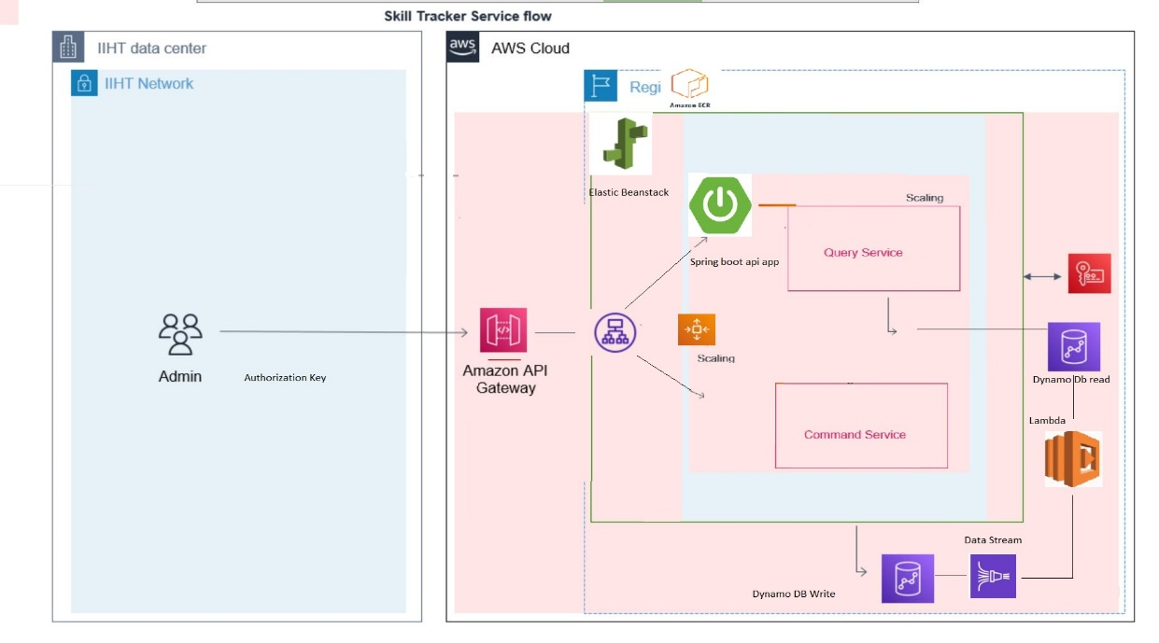

1. **UI Flow Architecture**

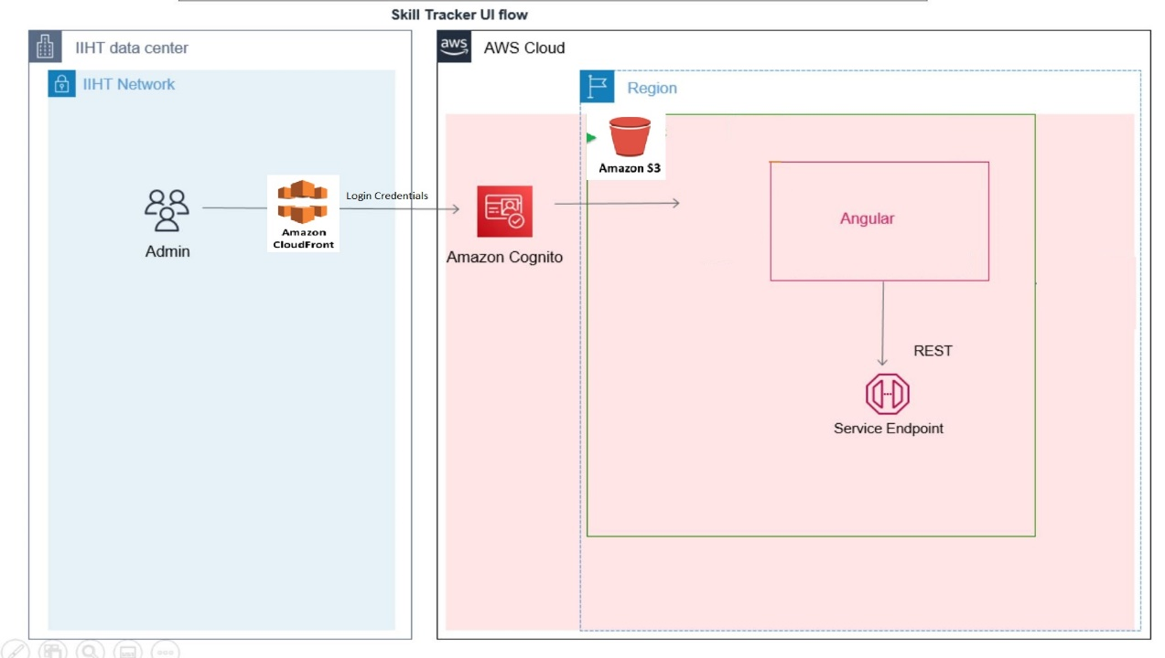

1. **UI Application Screen Shot**

**Login page**

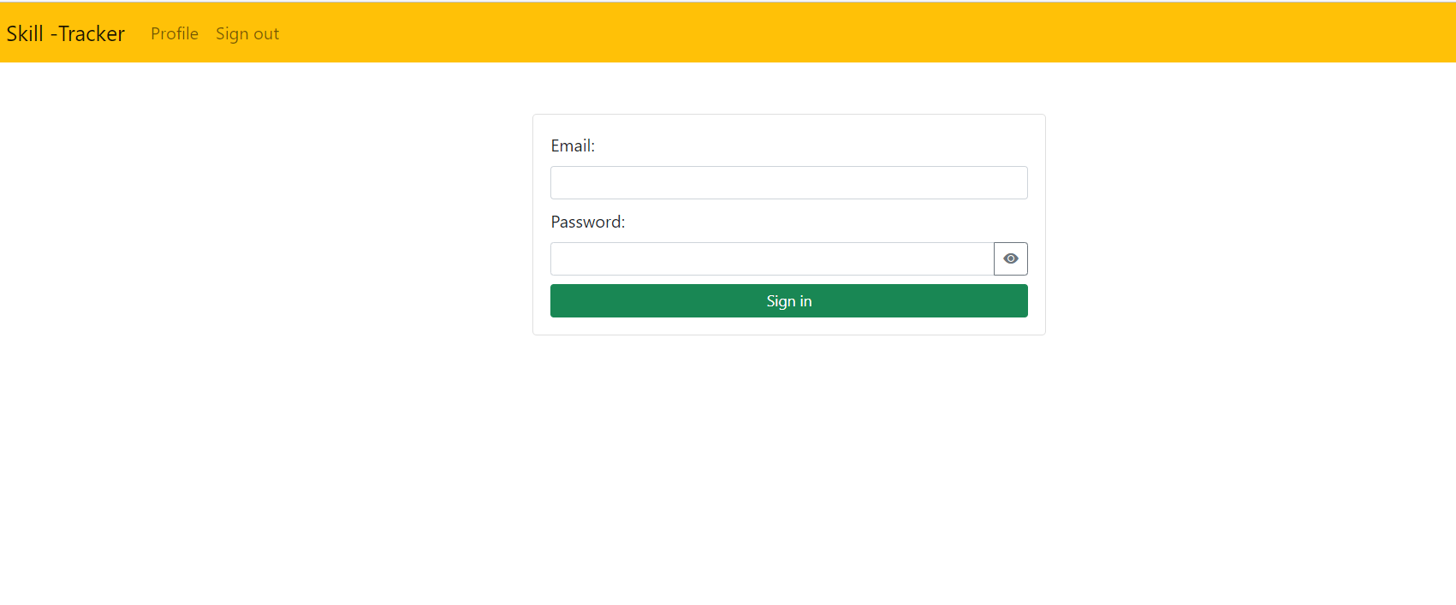

**Search screen**

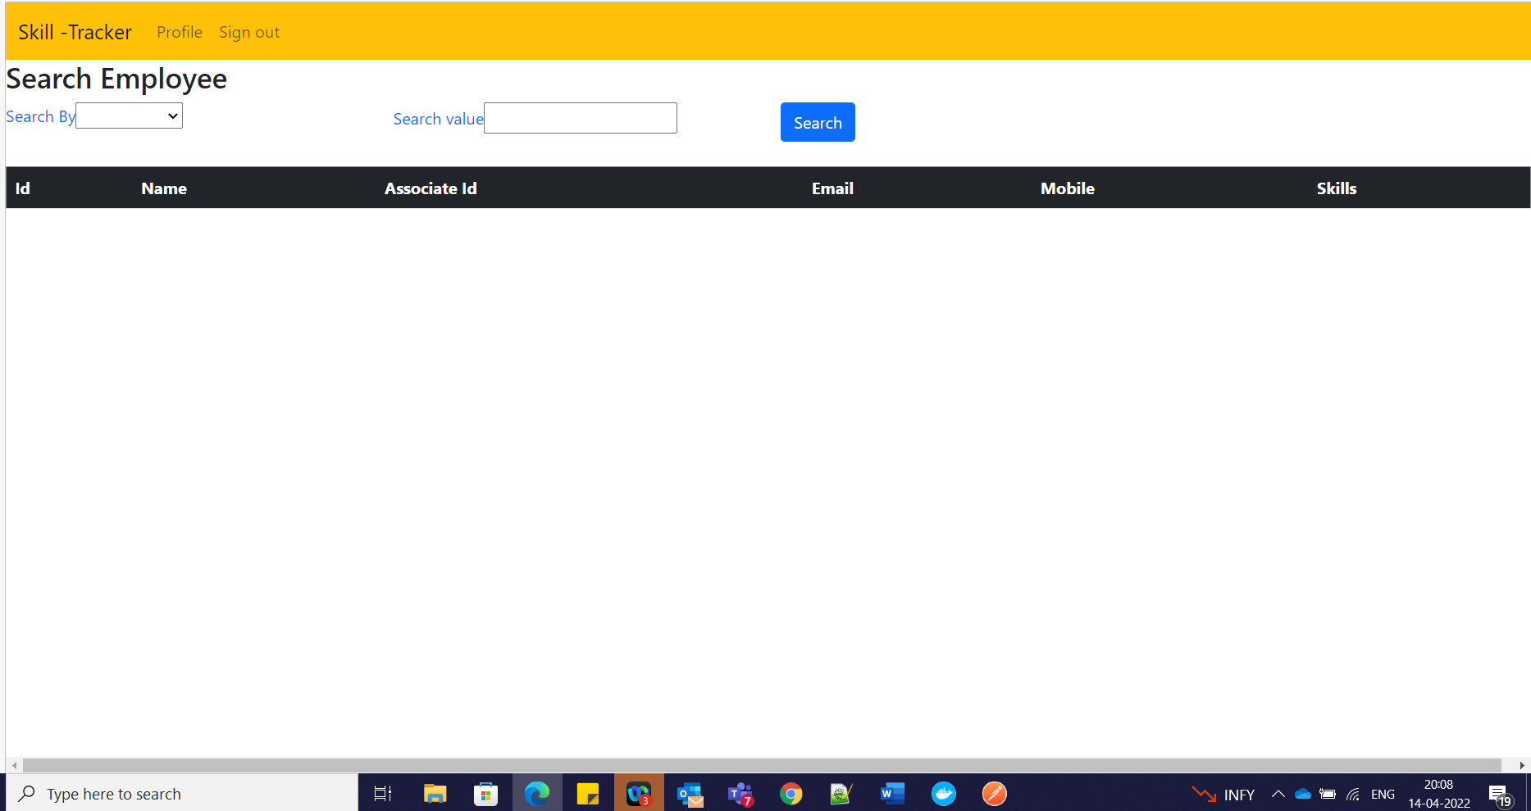

**Search Display**

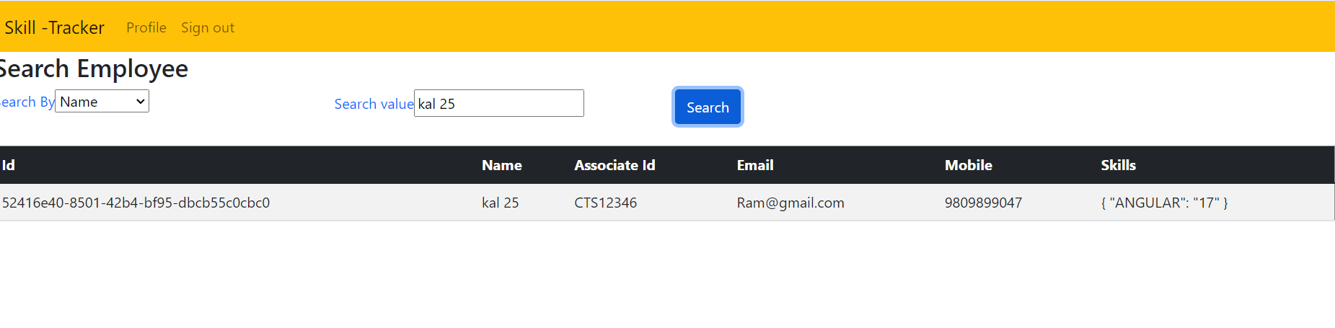

* **Dynamo DB Read and Write**

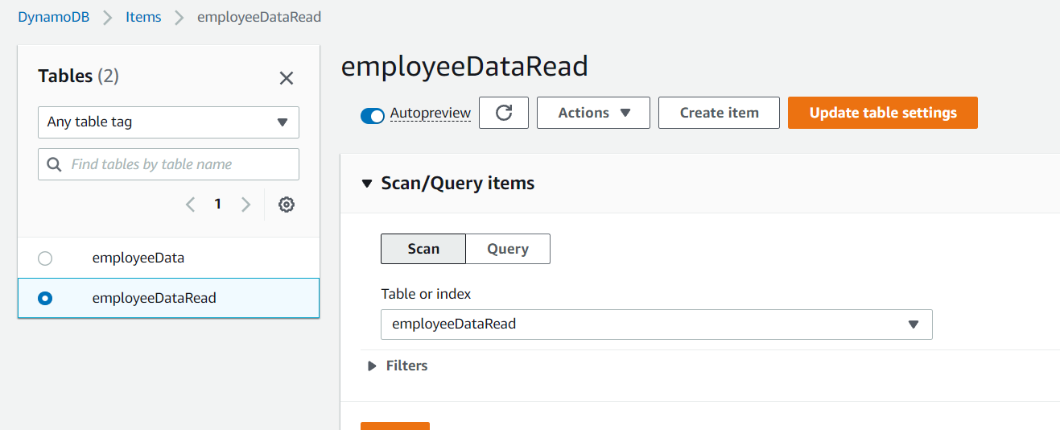

* **Lambda Cloud watch**

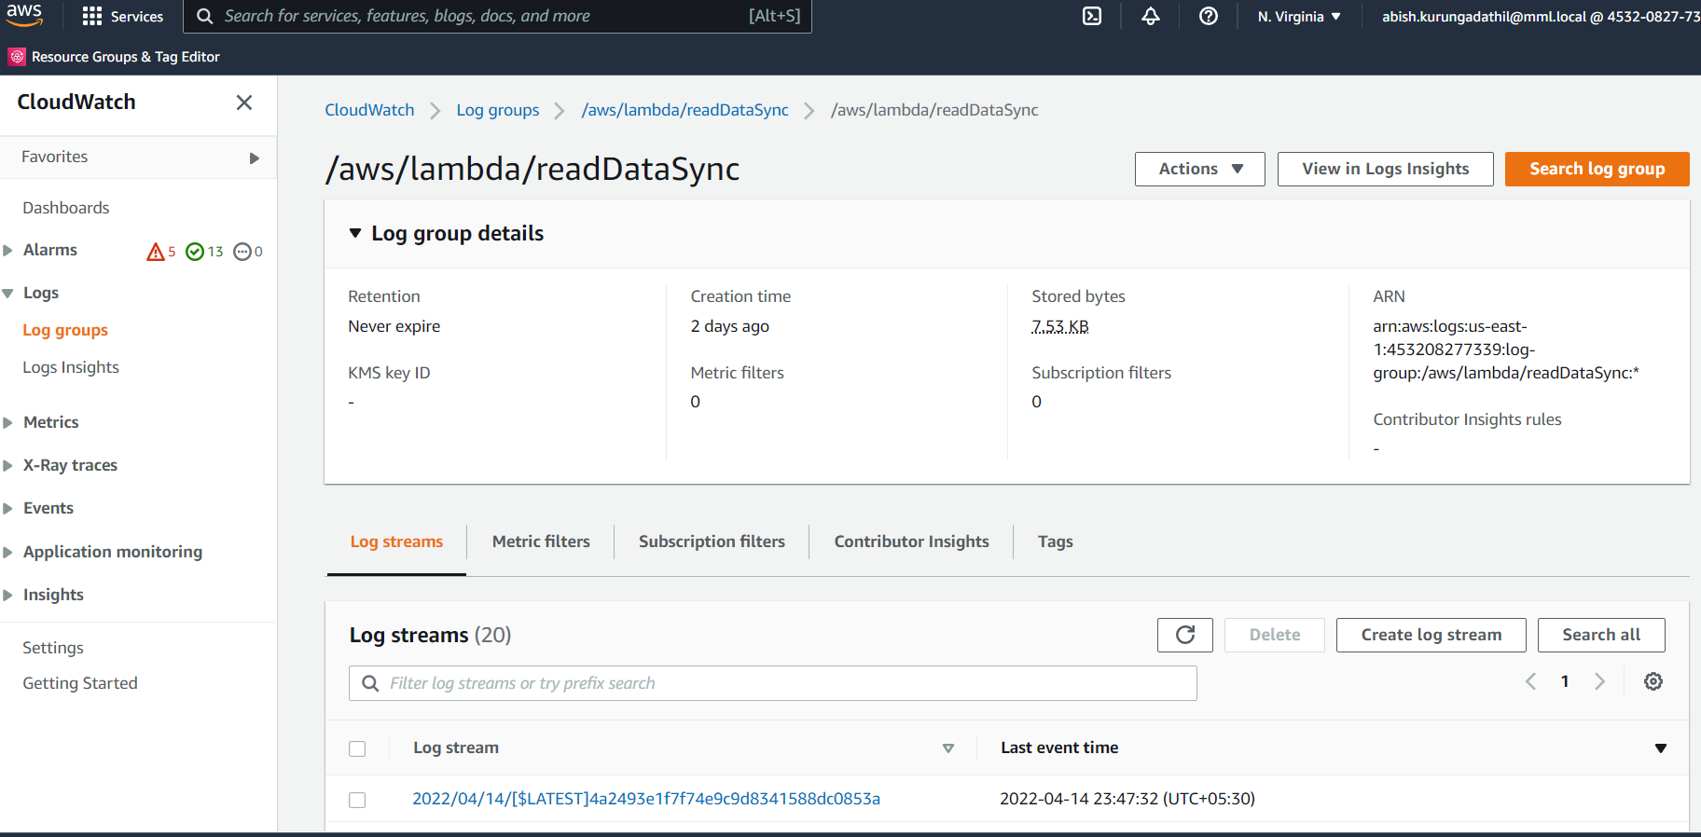

* **APIGATEWAY**

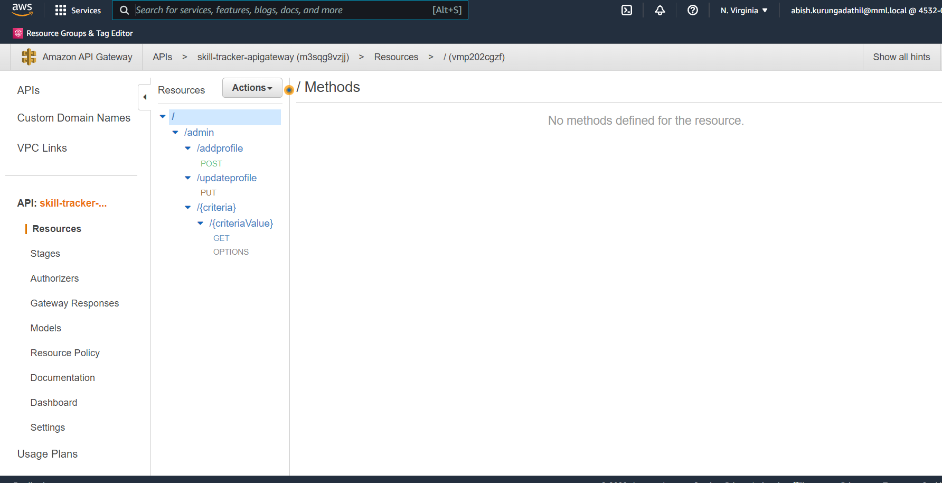

* **Testing Via Post man**

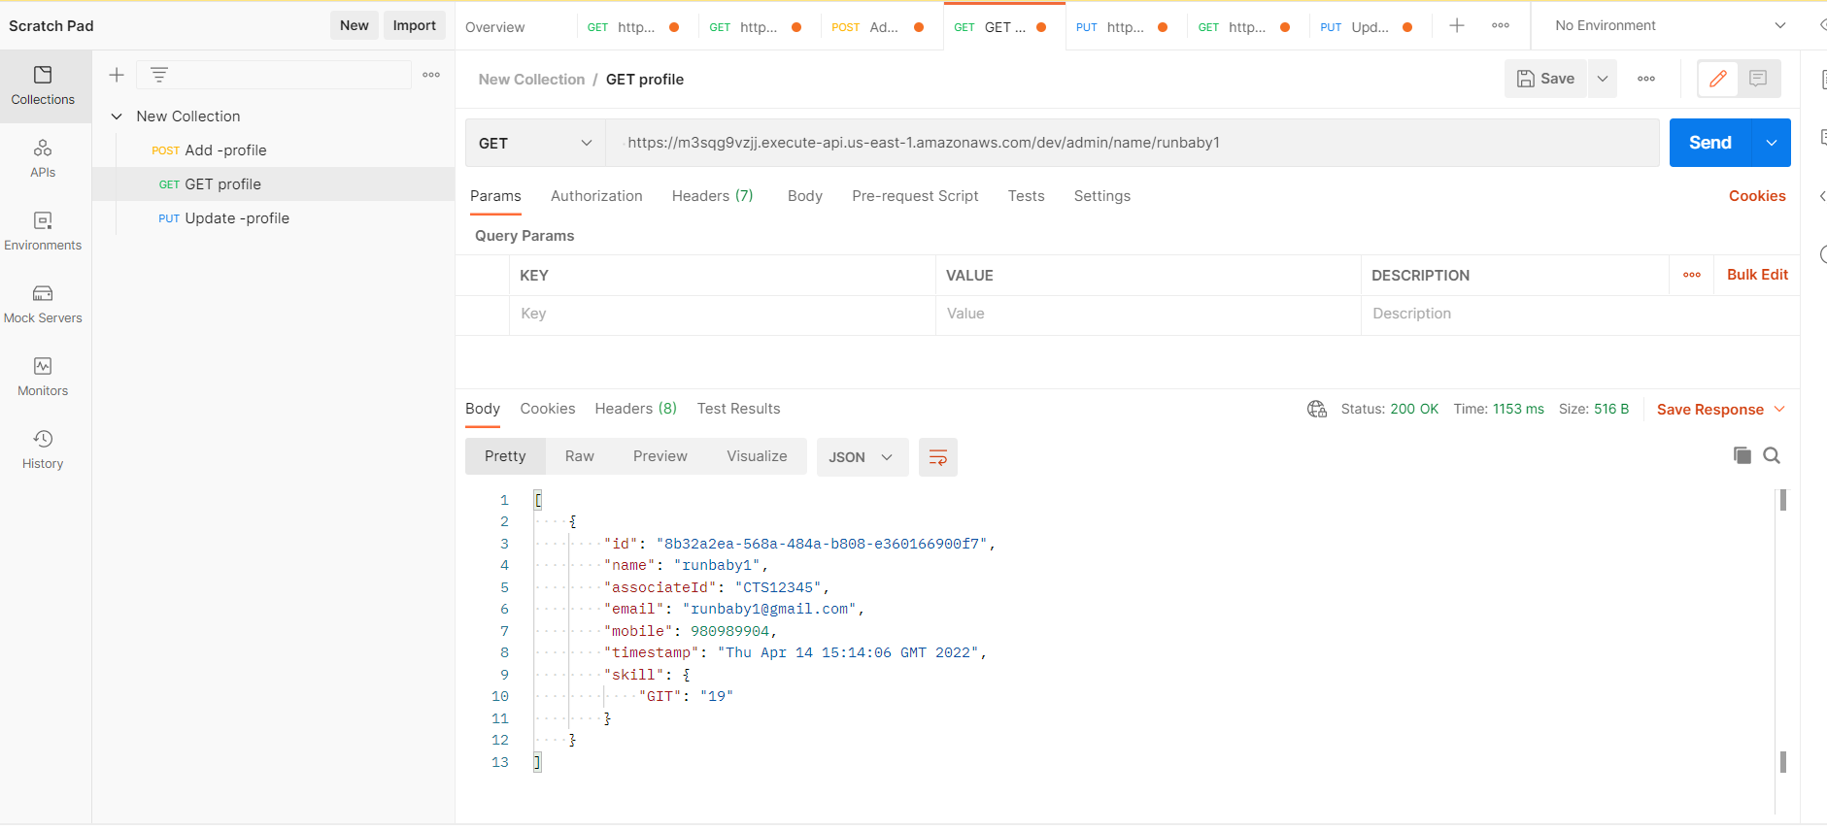

* **Swagger Screen shot**

